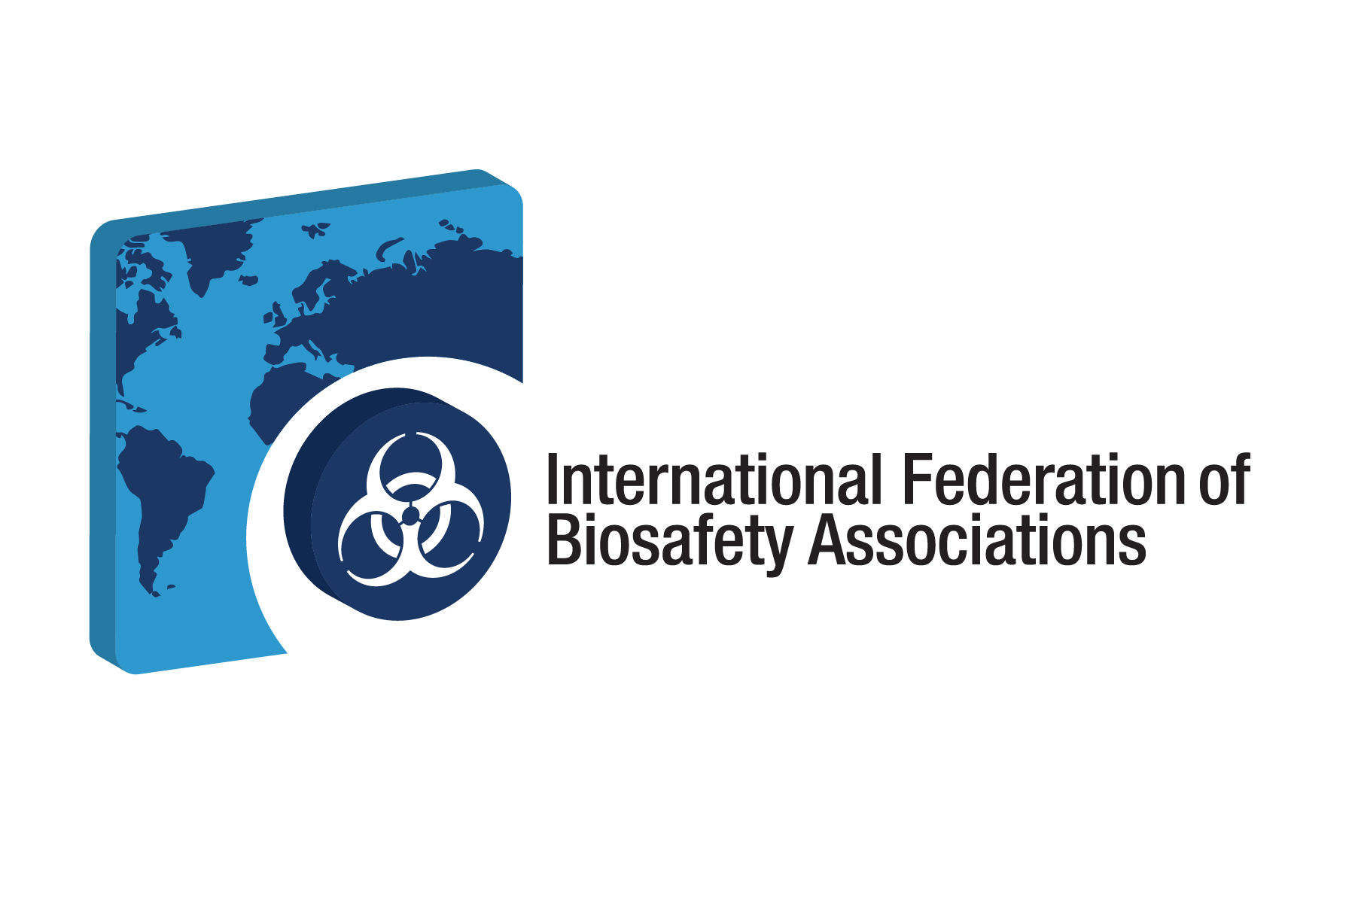


Application for Professional Certification Examination Grant in
“Biosafety Cabinet Selection, Installation and Safe Use”

The International Federation of Biosafety Associations (IFBA) is inviting applications for a NuAire www.nuaire.com funded grant to cover examination fees towards obtaining the IFBA’s Professional Certification in Biosafety Cabinet Selection, Installation and Safe Use. This certification identifies individuals with demonstrated competencies in the fundamental principles & practices of selecting and safely using biosafety cabinets for the handling of infectious materials. Candidates applying for this certification must have successfully completed the pre-requisite IFBA Professional Certification in Biorisk Management before they are eligible for this grant. For more information about the certification program, please visit www.internationalbiosafety.org.

Individuals who are interested in applying for the grant are requested to fill out the application form below and forward by email together with a copy of their curriculum vitae to the IFBA Secretariat at: secretariat@internationalbiosafety.org . NuAire will be providing 10 grants throughout 2025. Please apply early as grants will be awarded on a first come, first serve basis.

Please note that this grant opportunity is only available to candidates who
- are English speaking (the Biosafety Cabinet examination will be delivered through the IFBA’s online Prolydian/Proctor360 platform which at this time, is available in English only)
- currently hold a valid IFBA Professional Certification in Biorisk Management
- work with, use and/or have responsibility for maintaining biological safety cabinets; and,
- are familiar with the IFBA Biosafety Cabinet Selection Installation & Safety Use Exam Content Study Guide

a) Candidate Contact Information
1) First Name, Last Name
2) Country of Citizenship*
3) Country of Current Employment/Study*
4) Language Spoken, Written (i.e. indicate your ability to sit for an online examination in the English language)
*All applications/applicants are subject to US Law and review according to US export regulations
5) Mailing Address
6) Telephone/Fax
7) Email Address
b) Candidate Profile
8) Title and Brief Job Description (Please describe your job responsibilities and areas of expertise)
9) Please describe how earning a Professional Certification in Biosafety Cabinets is relevant to your current career goals and advancing biorisk management within your organization.

Copy of Curriculum Vitae attached

I confirm that all information given is correct at the time of completing this application

Signature Date

